9/11/21 + 19/11

FIRST GRAPHICAL ANALYSIS OF EVENTS:  
Added LAMPINET data to Italian events, + new data received from Kris and OT delta temperature -> events by chronological order:  
10 July 2019 - Pescara (central Italy): hail size record 15cm

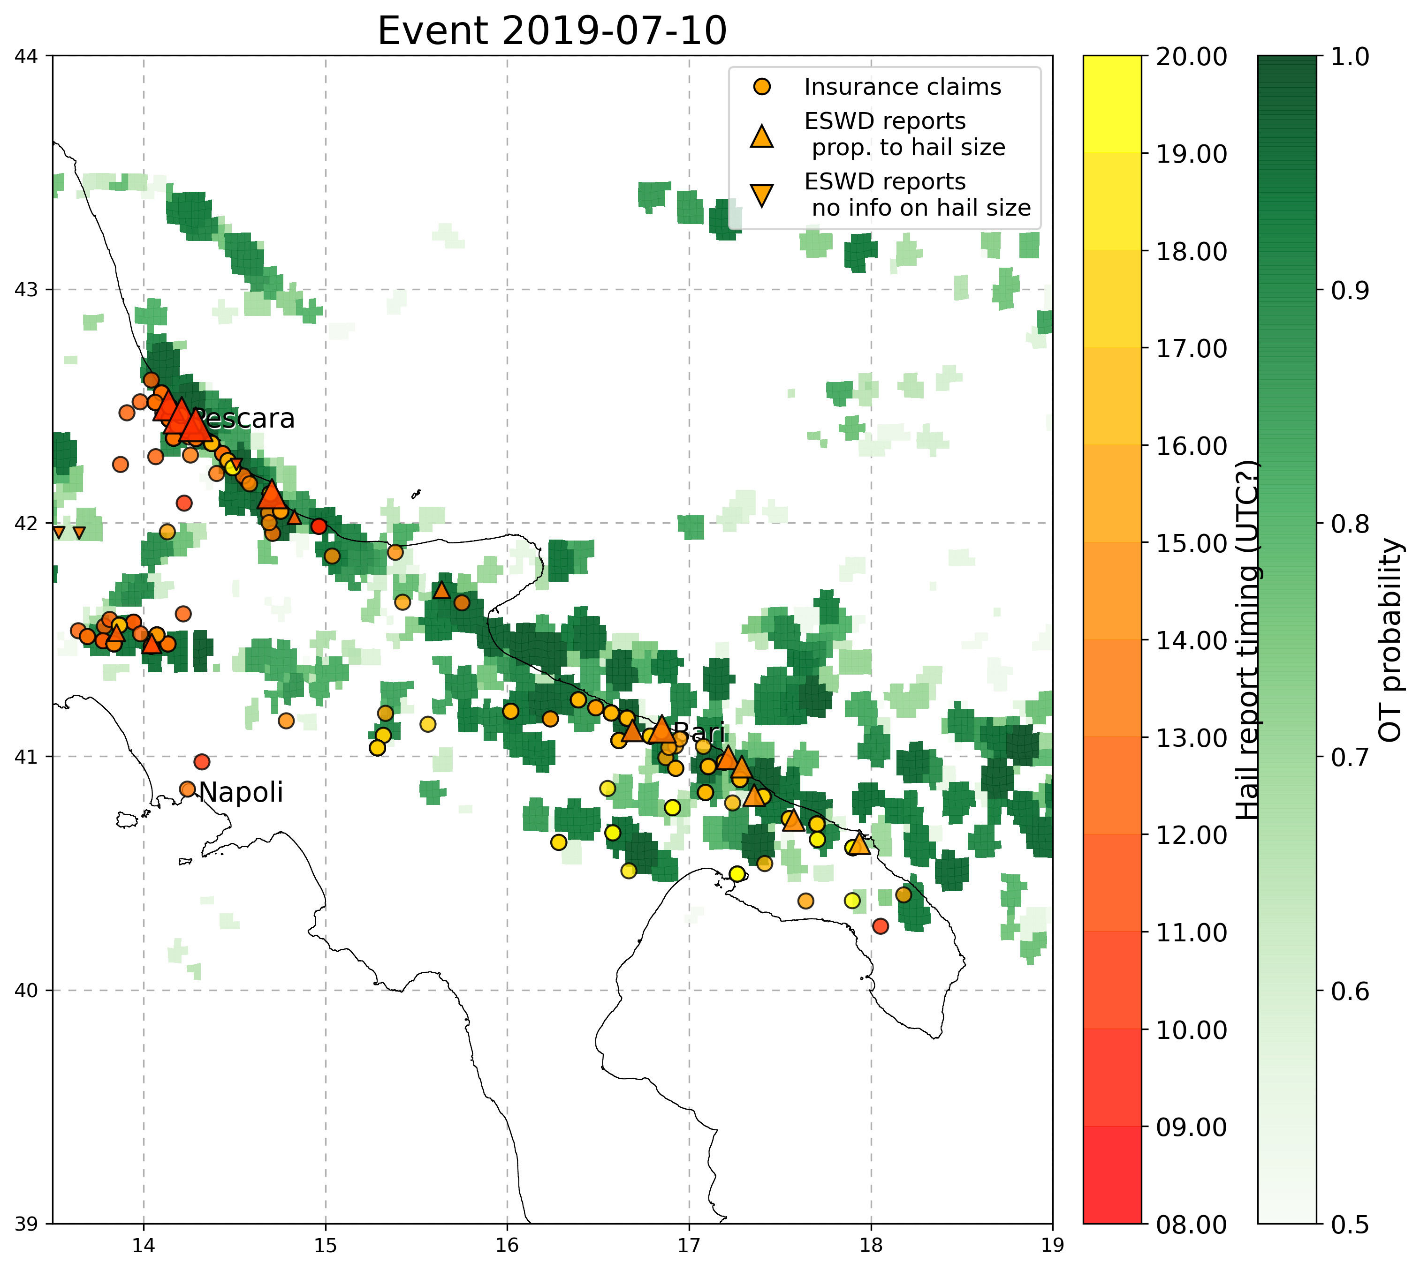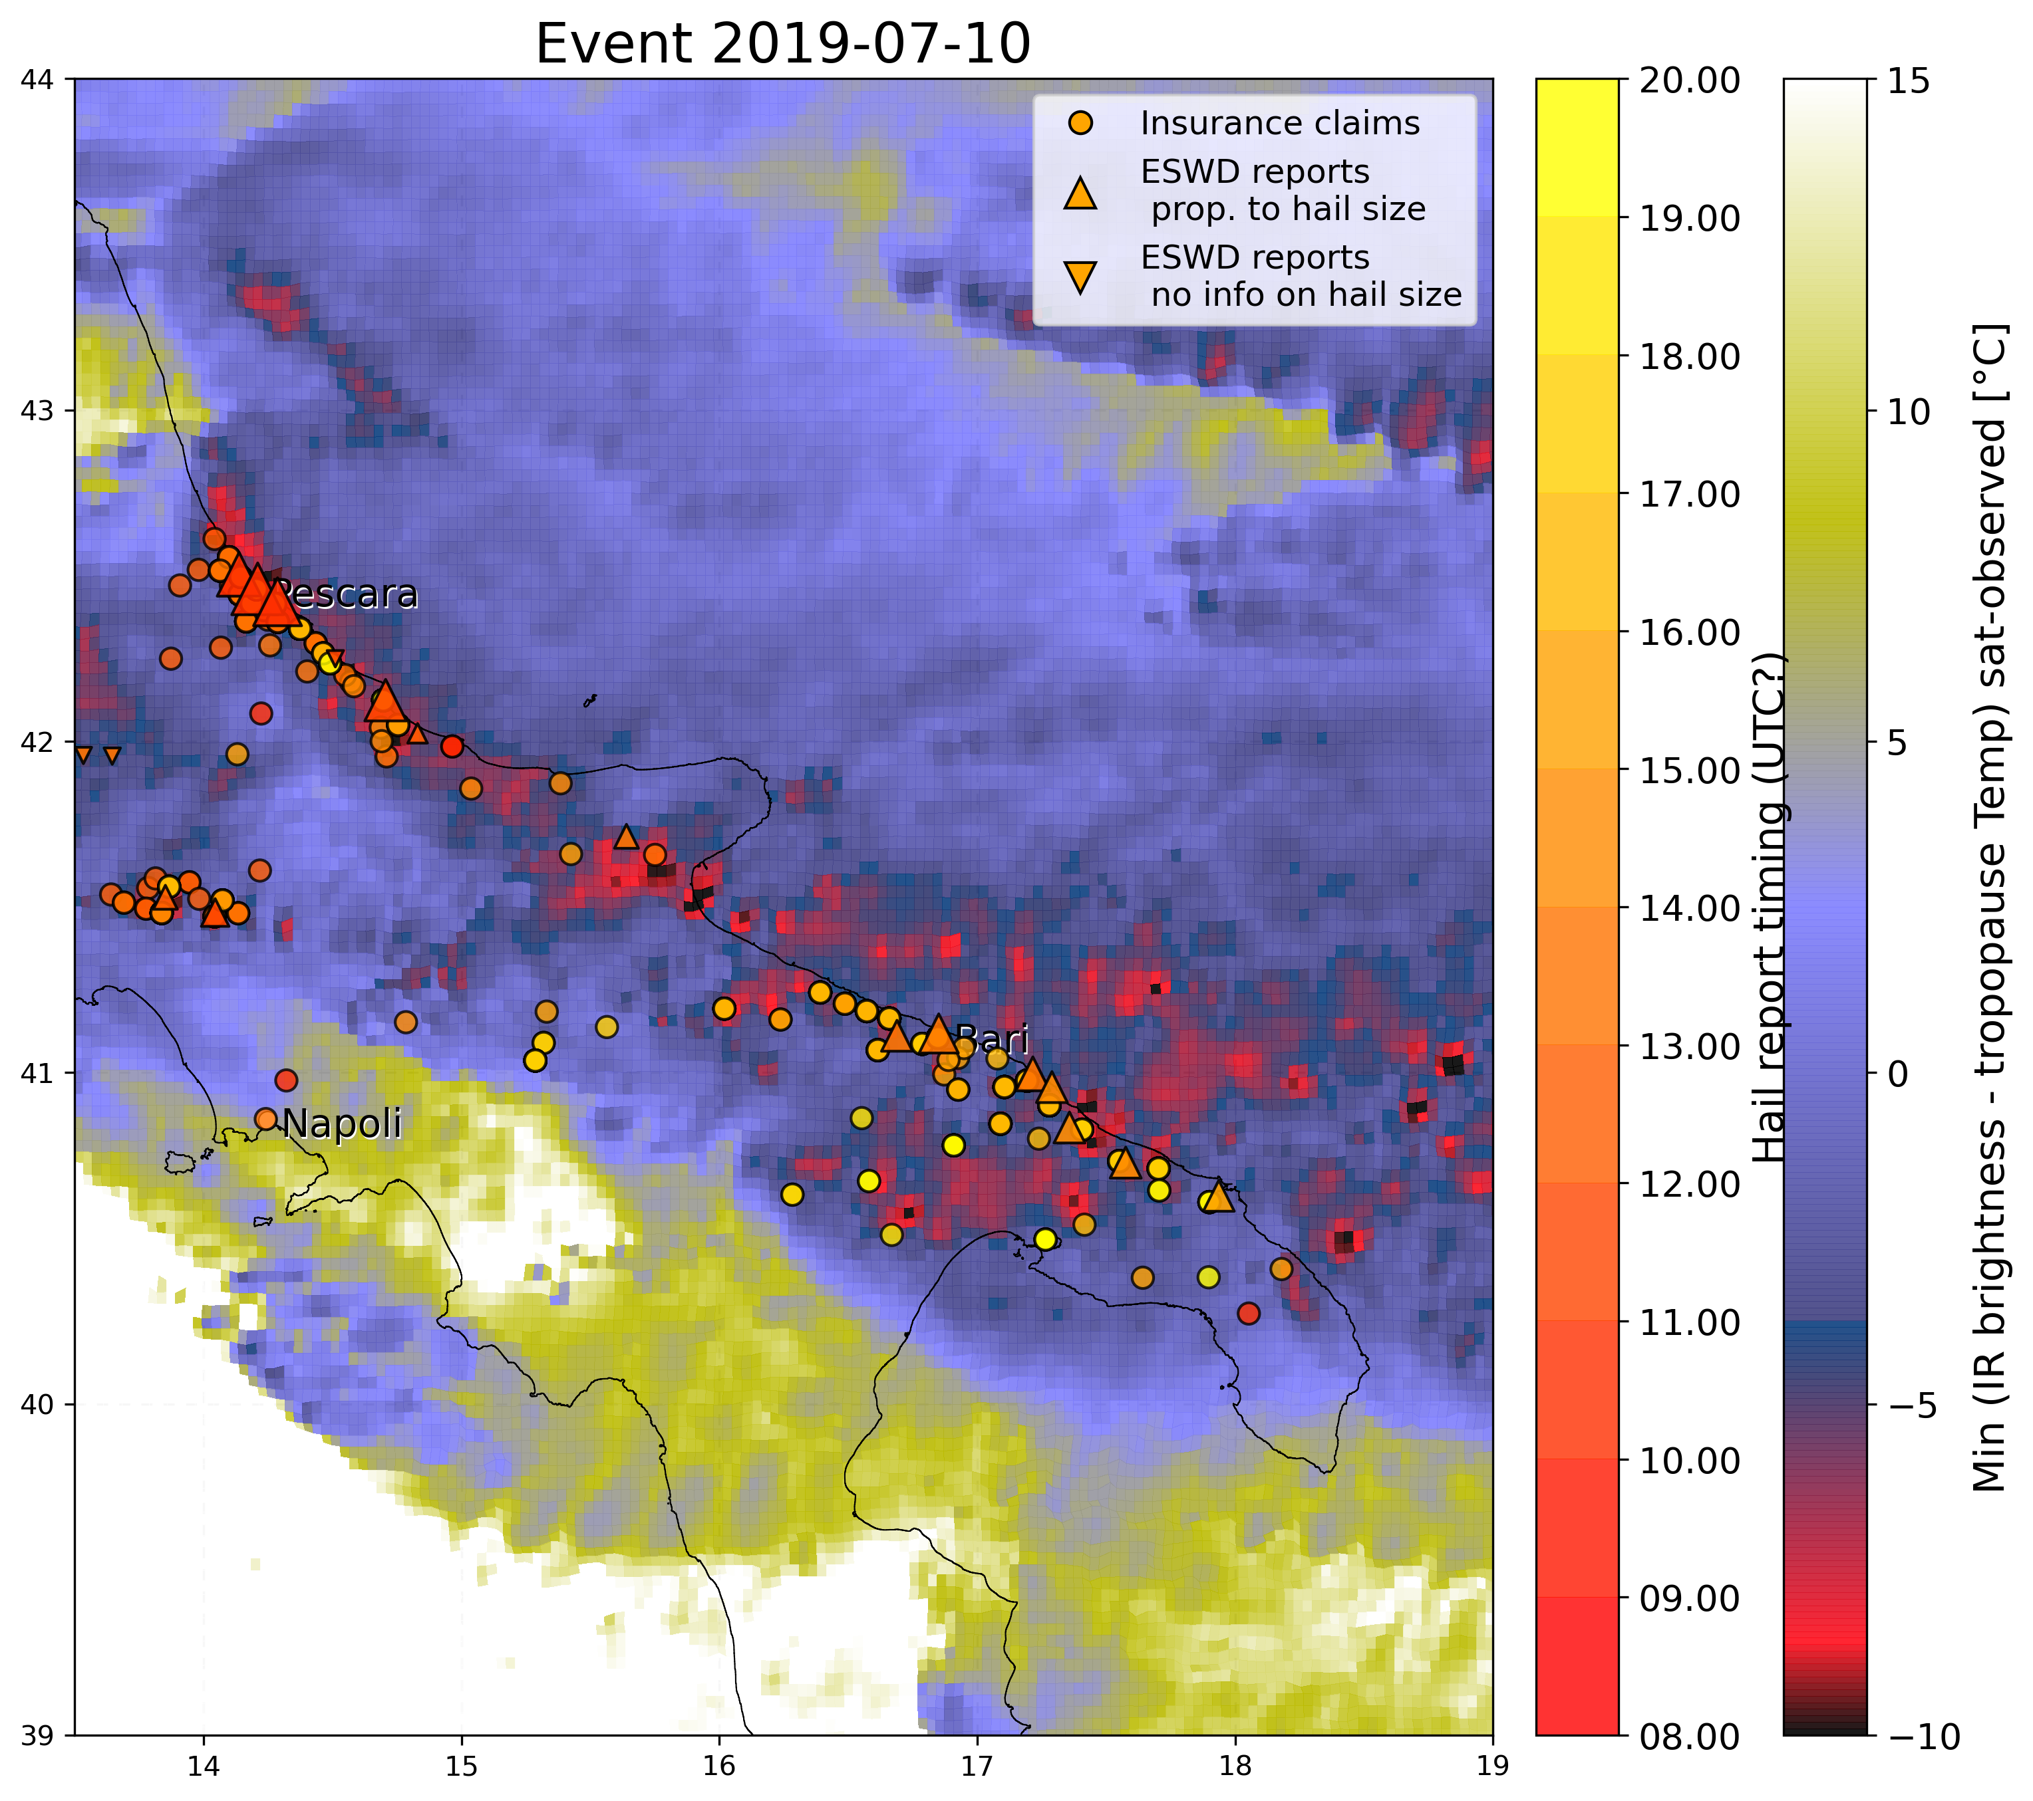

2. 29 **October** 2018 - Sardinia:

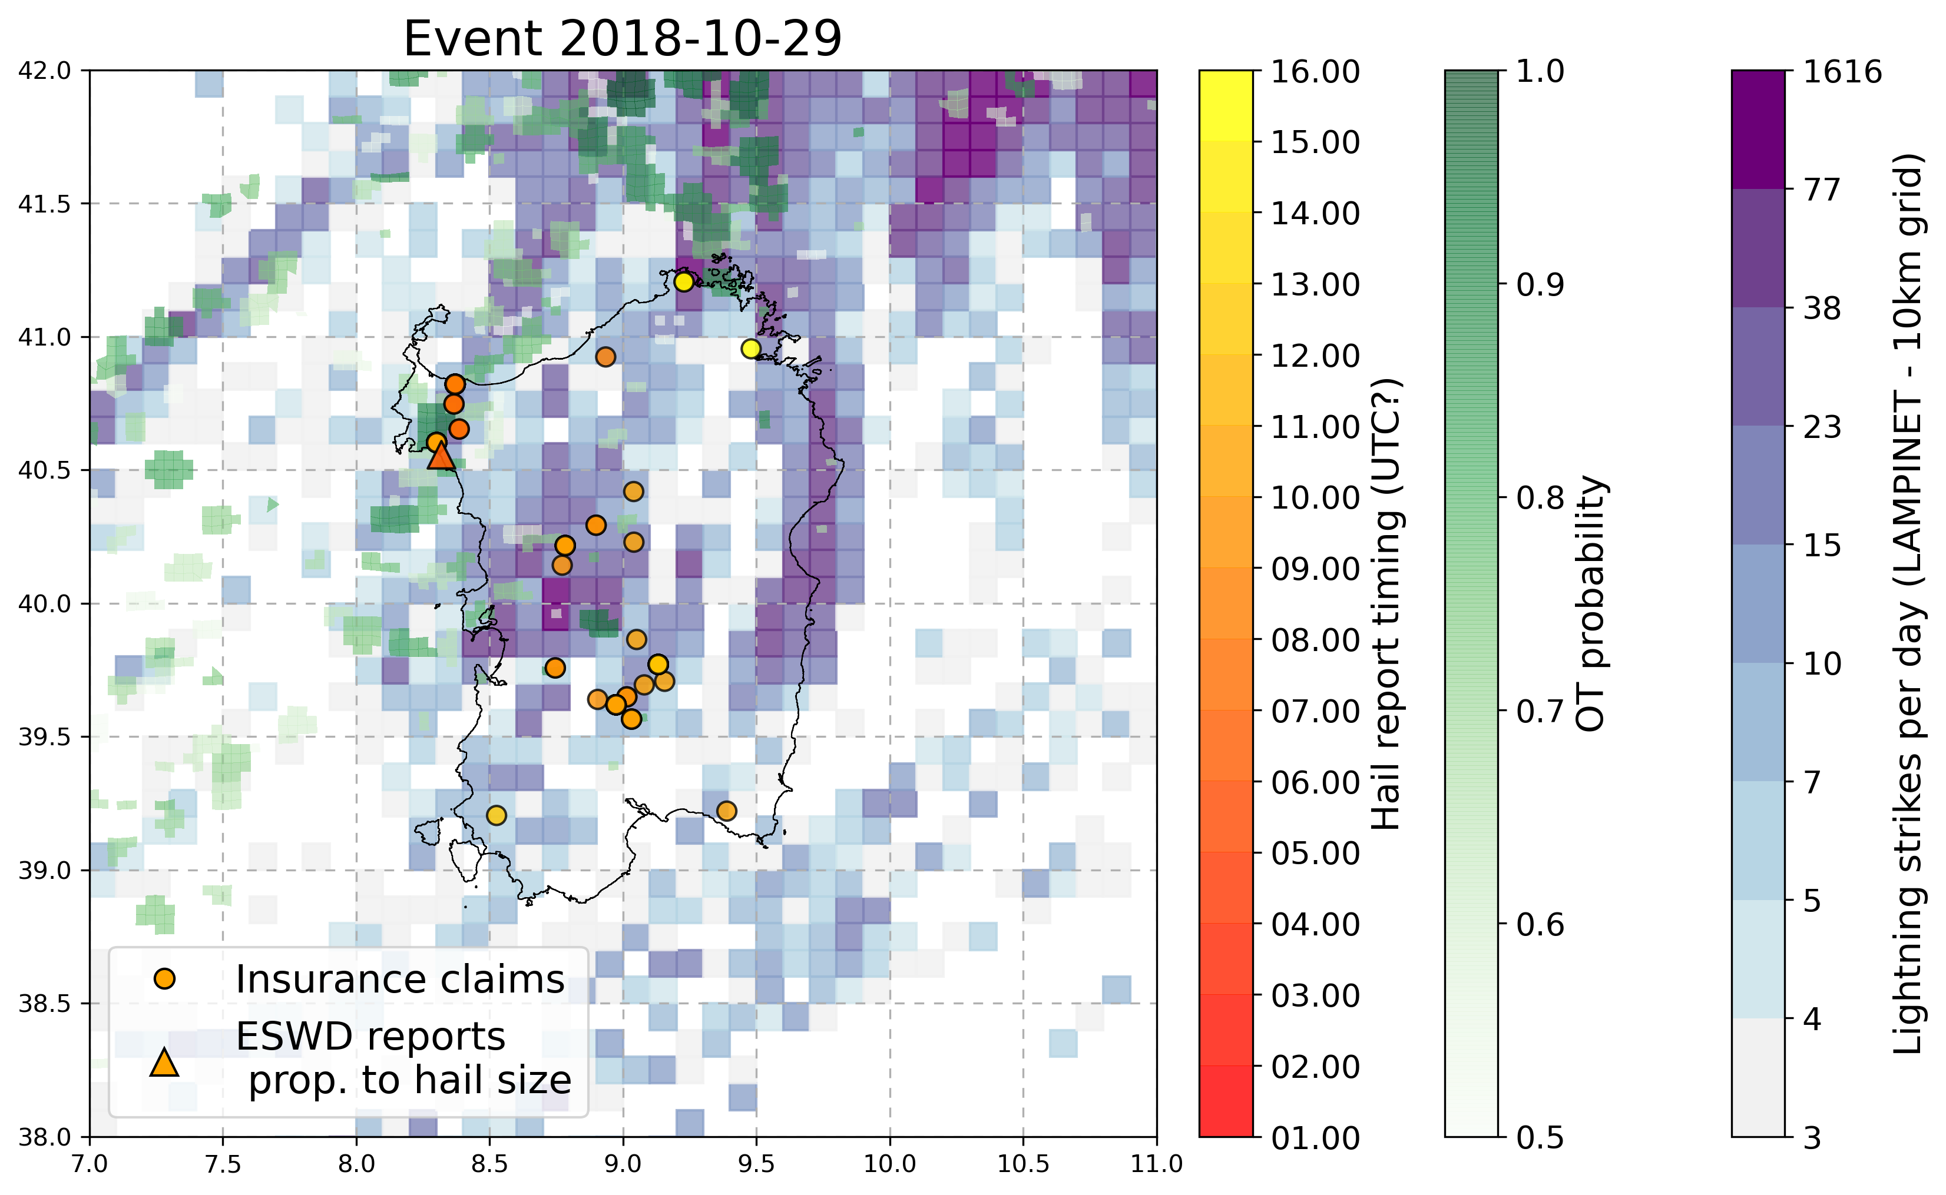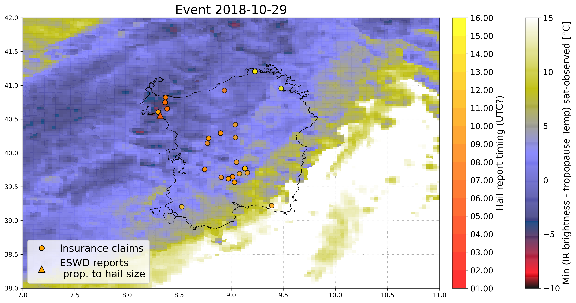

3. 4 June 2018 - Parma, Emilia Romagna Italy

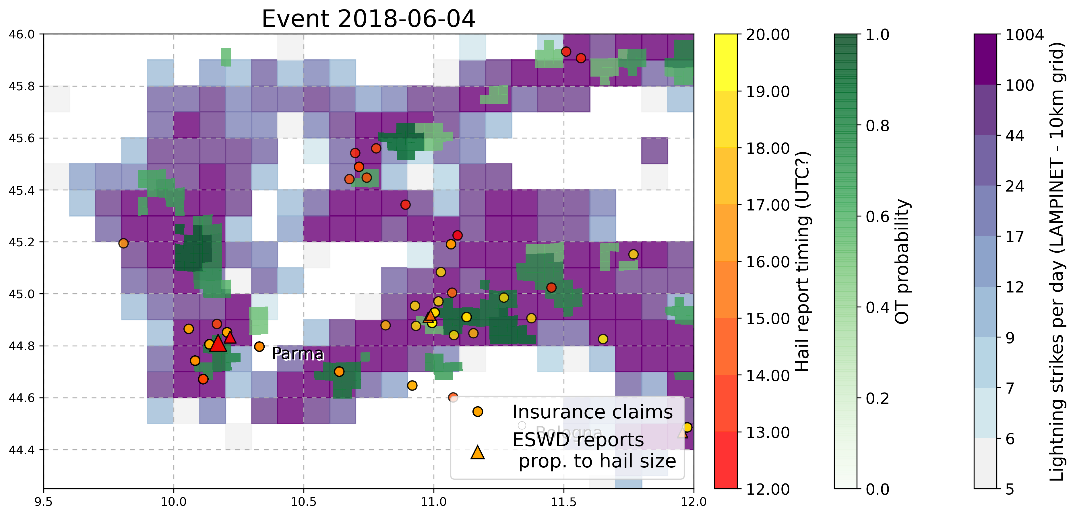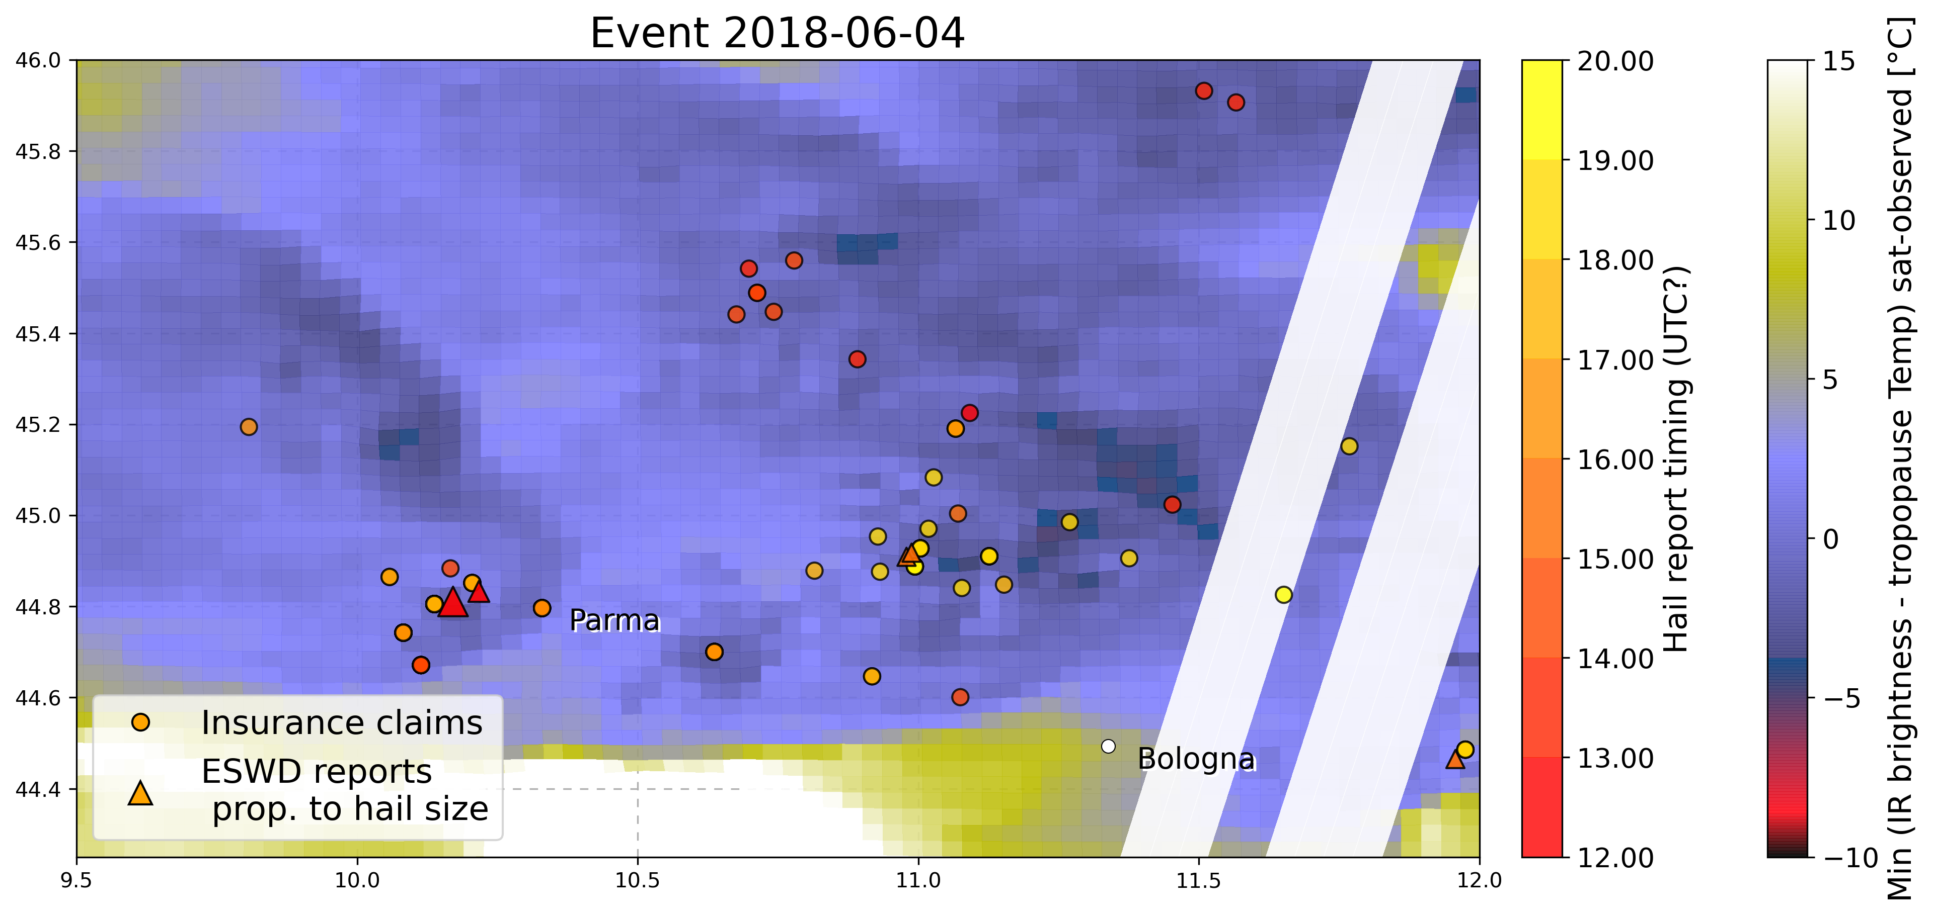

5. 18 August 2017 - Bohringen (Romerstein) SWGermany

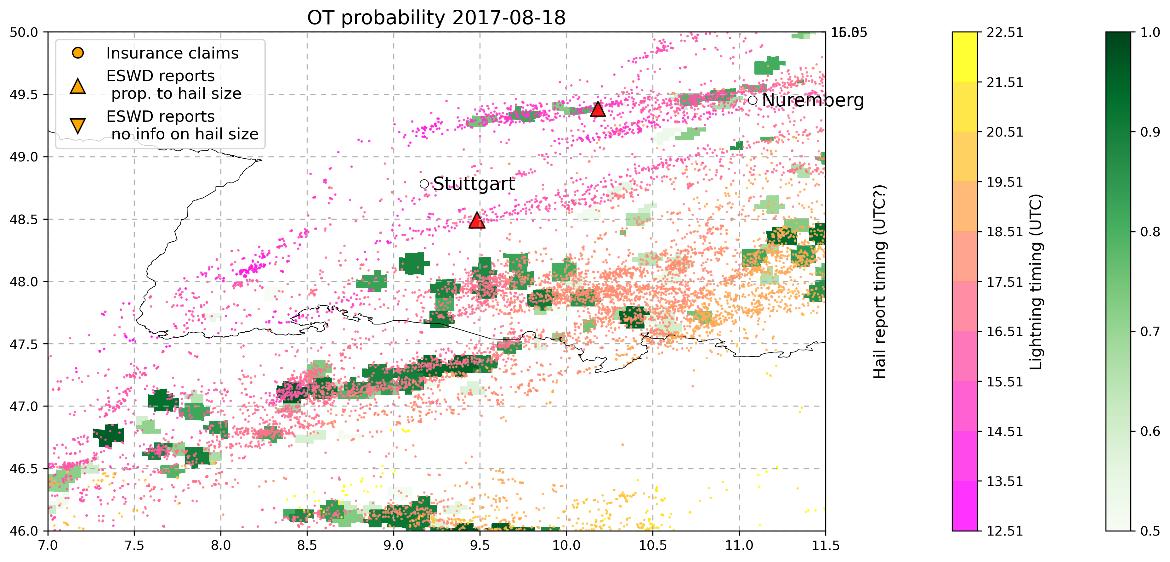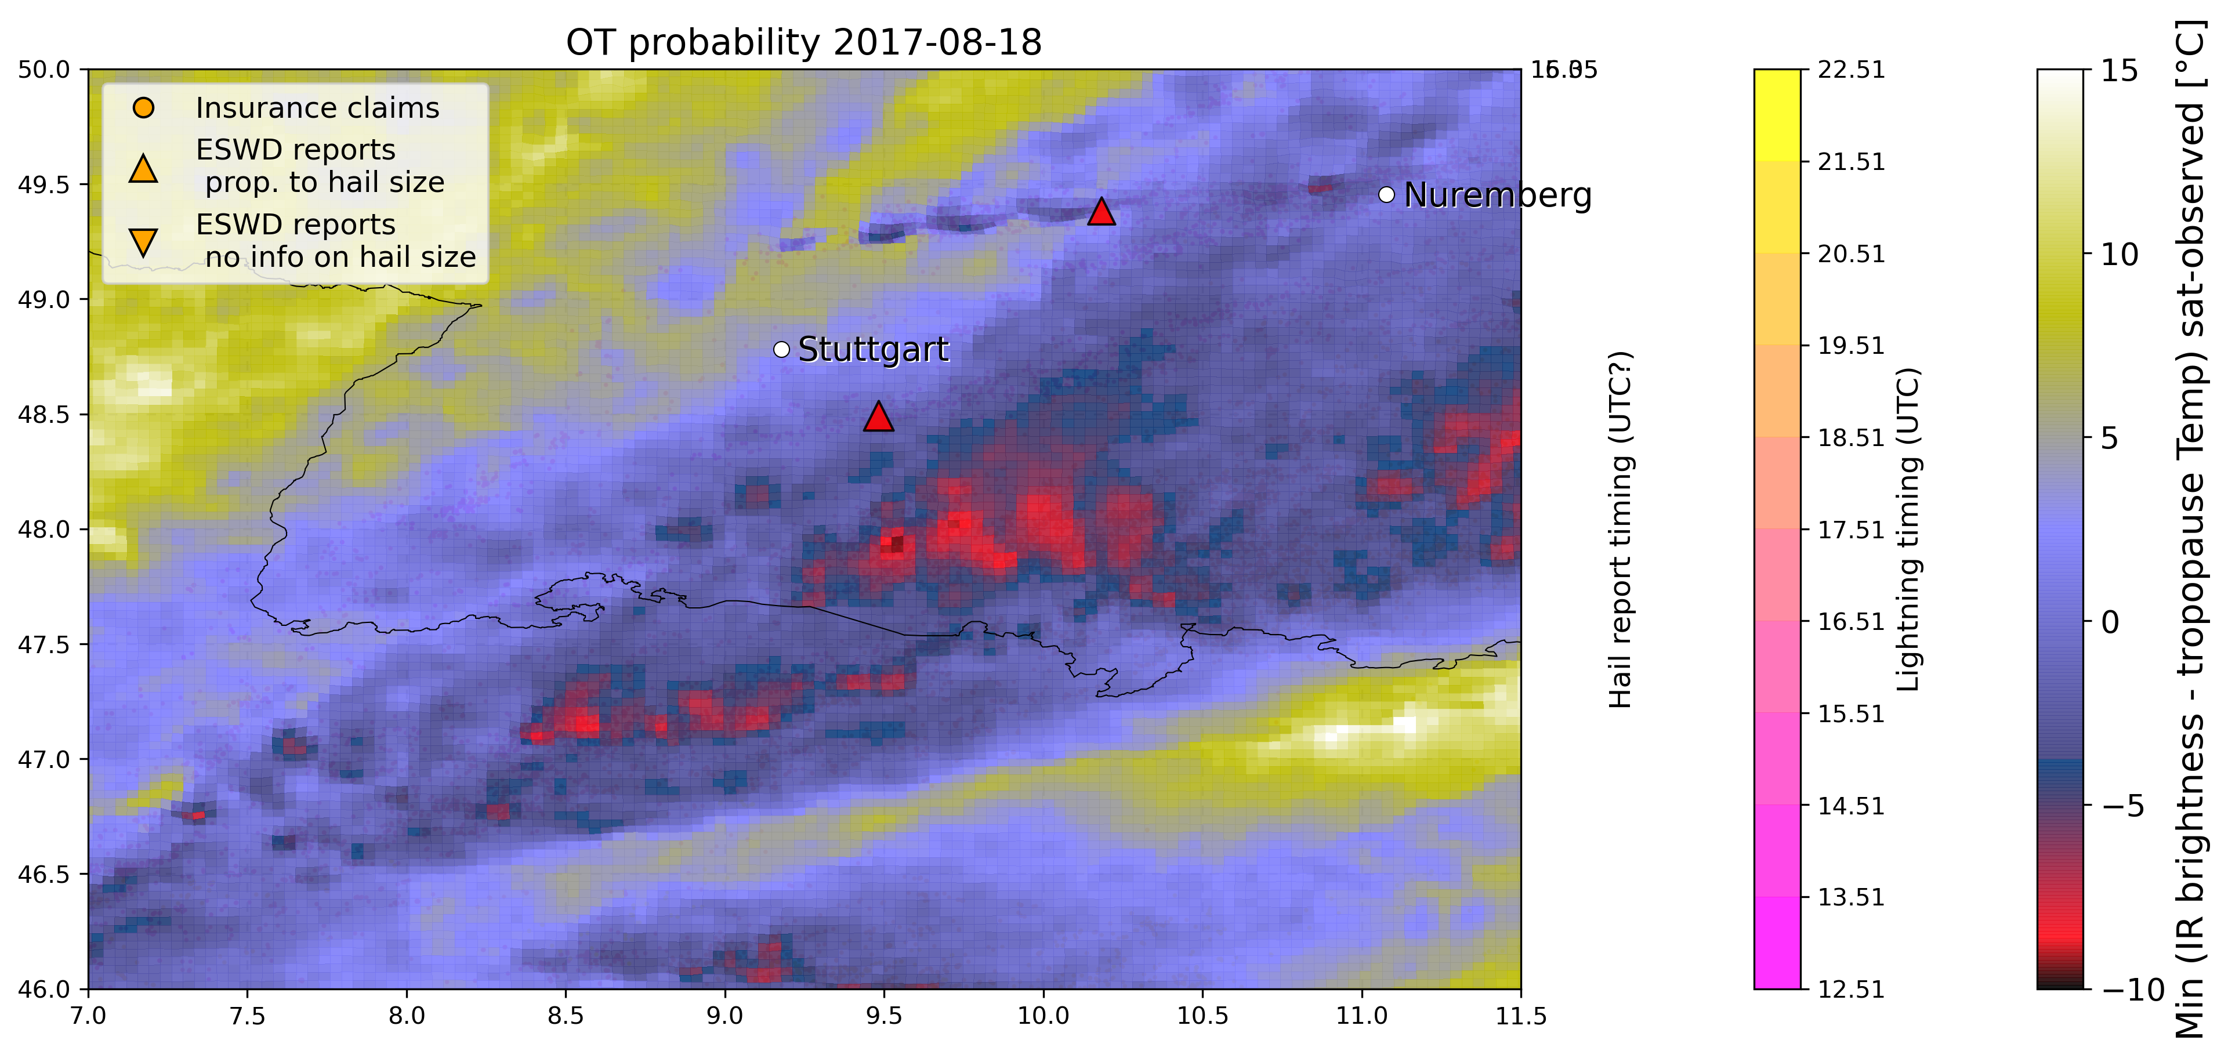

6. 29 July 2017 - Piacenza (Nord Italy)

No eswd nor insurance data available even if the event is well reported in newspapers (https://www.ansa.it/emiliaromagna/notizie/2017/07/29/grandinata-nel-piacentino-allagamenti_bc277294-62b2-464e-a3f0-92030c001810.html), and a well defined OT pattern is very evident coupled with lightning temporal evolution.

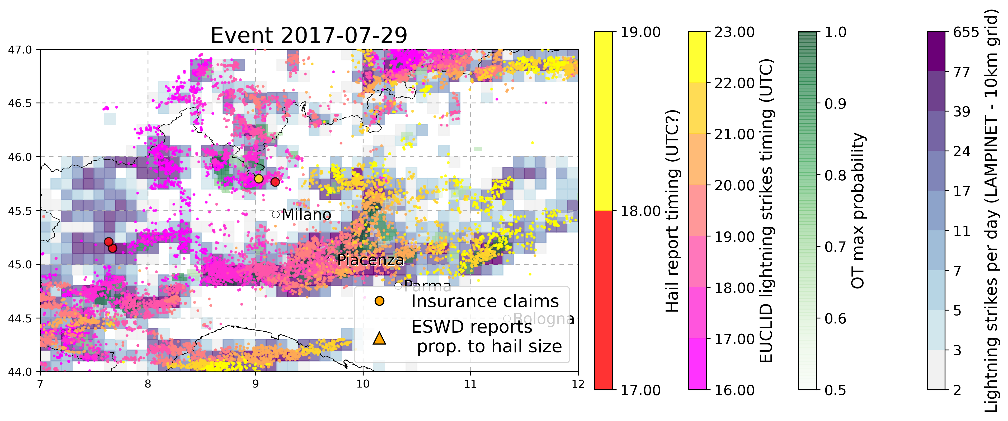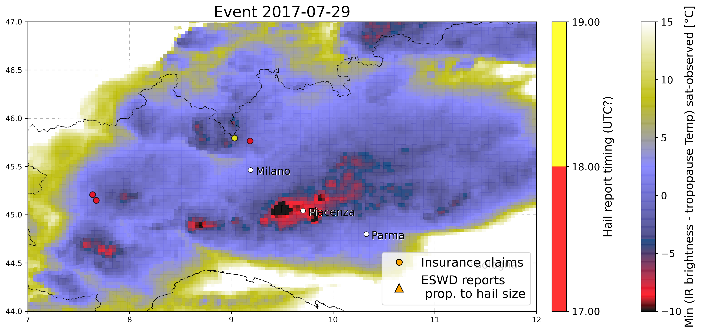

7. 24 June 2016 - Dettingen bei Rottemburg (SWGermany)

Only two eswd reports, still need to add insurance data, OT data MAYBE related to wrong day ?? (julian day of .nc data is 176 while 24 Jun should be 175 - NO it is right as 2016 is a leap year!)

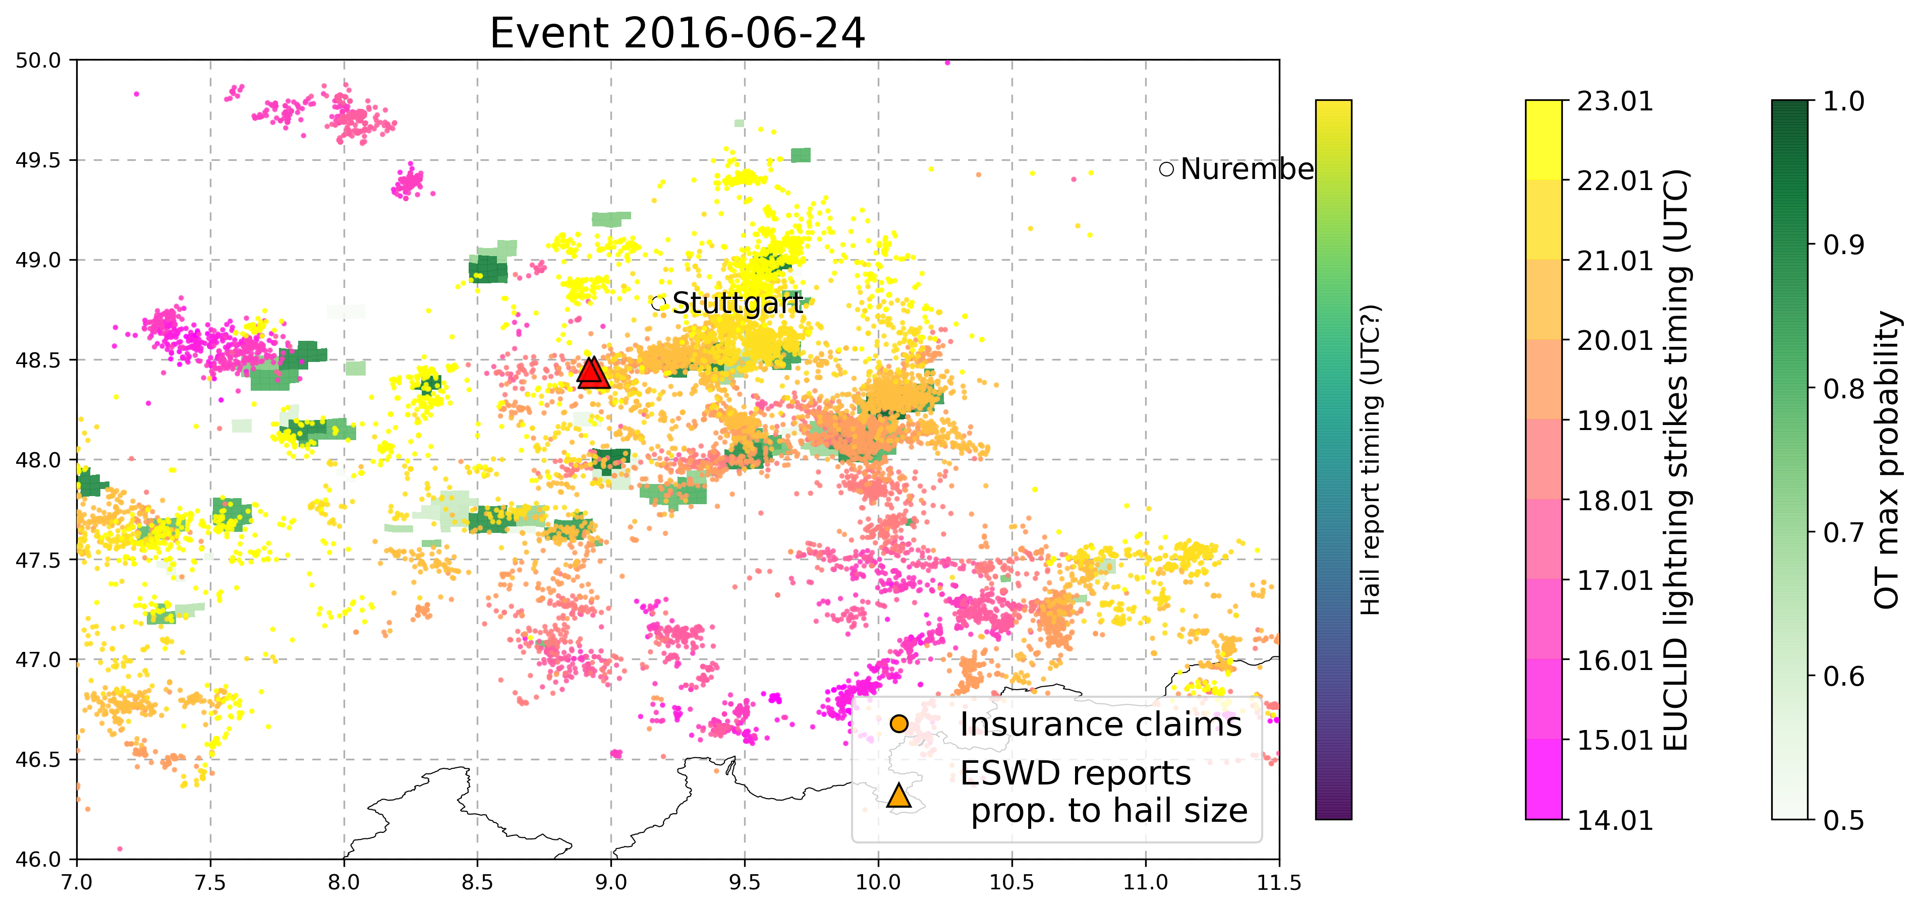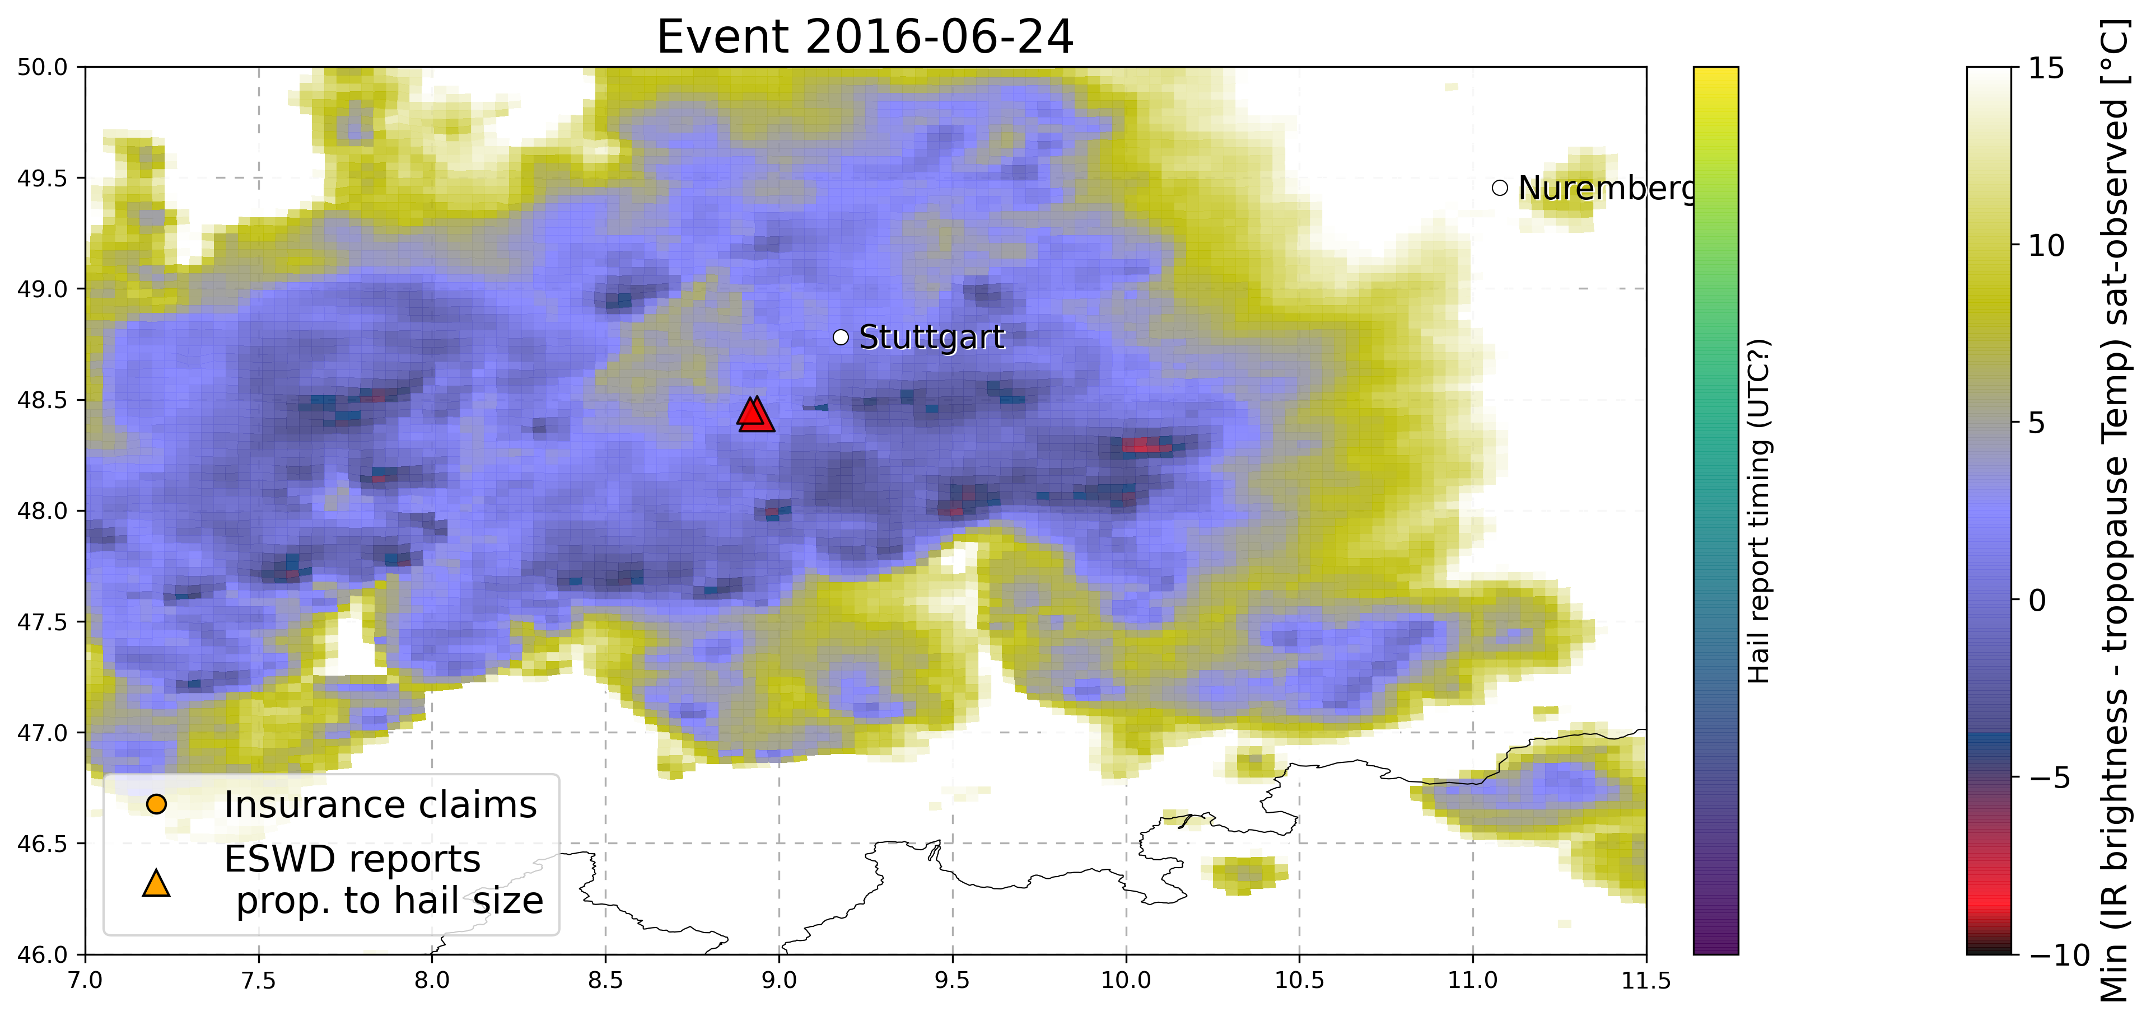

8. 5 September 2015 - Napoli (south Italy)

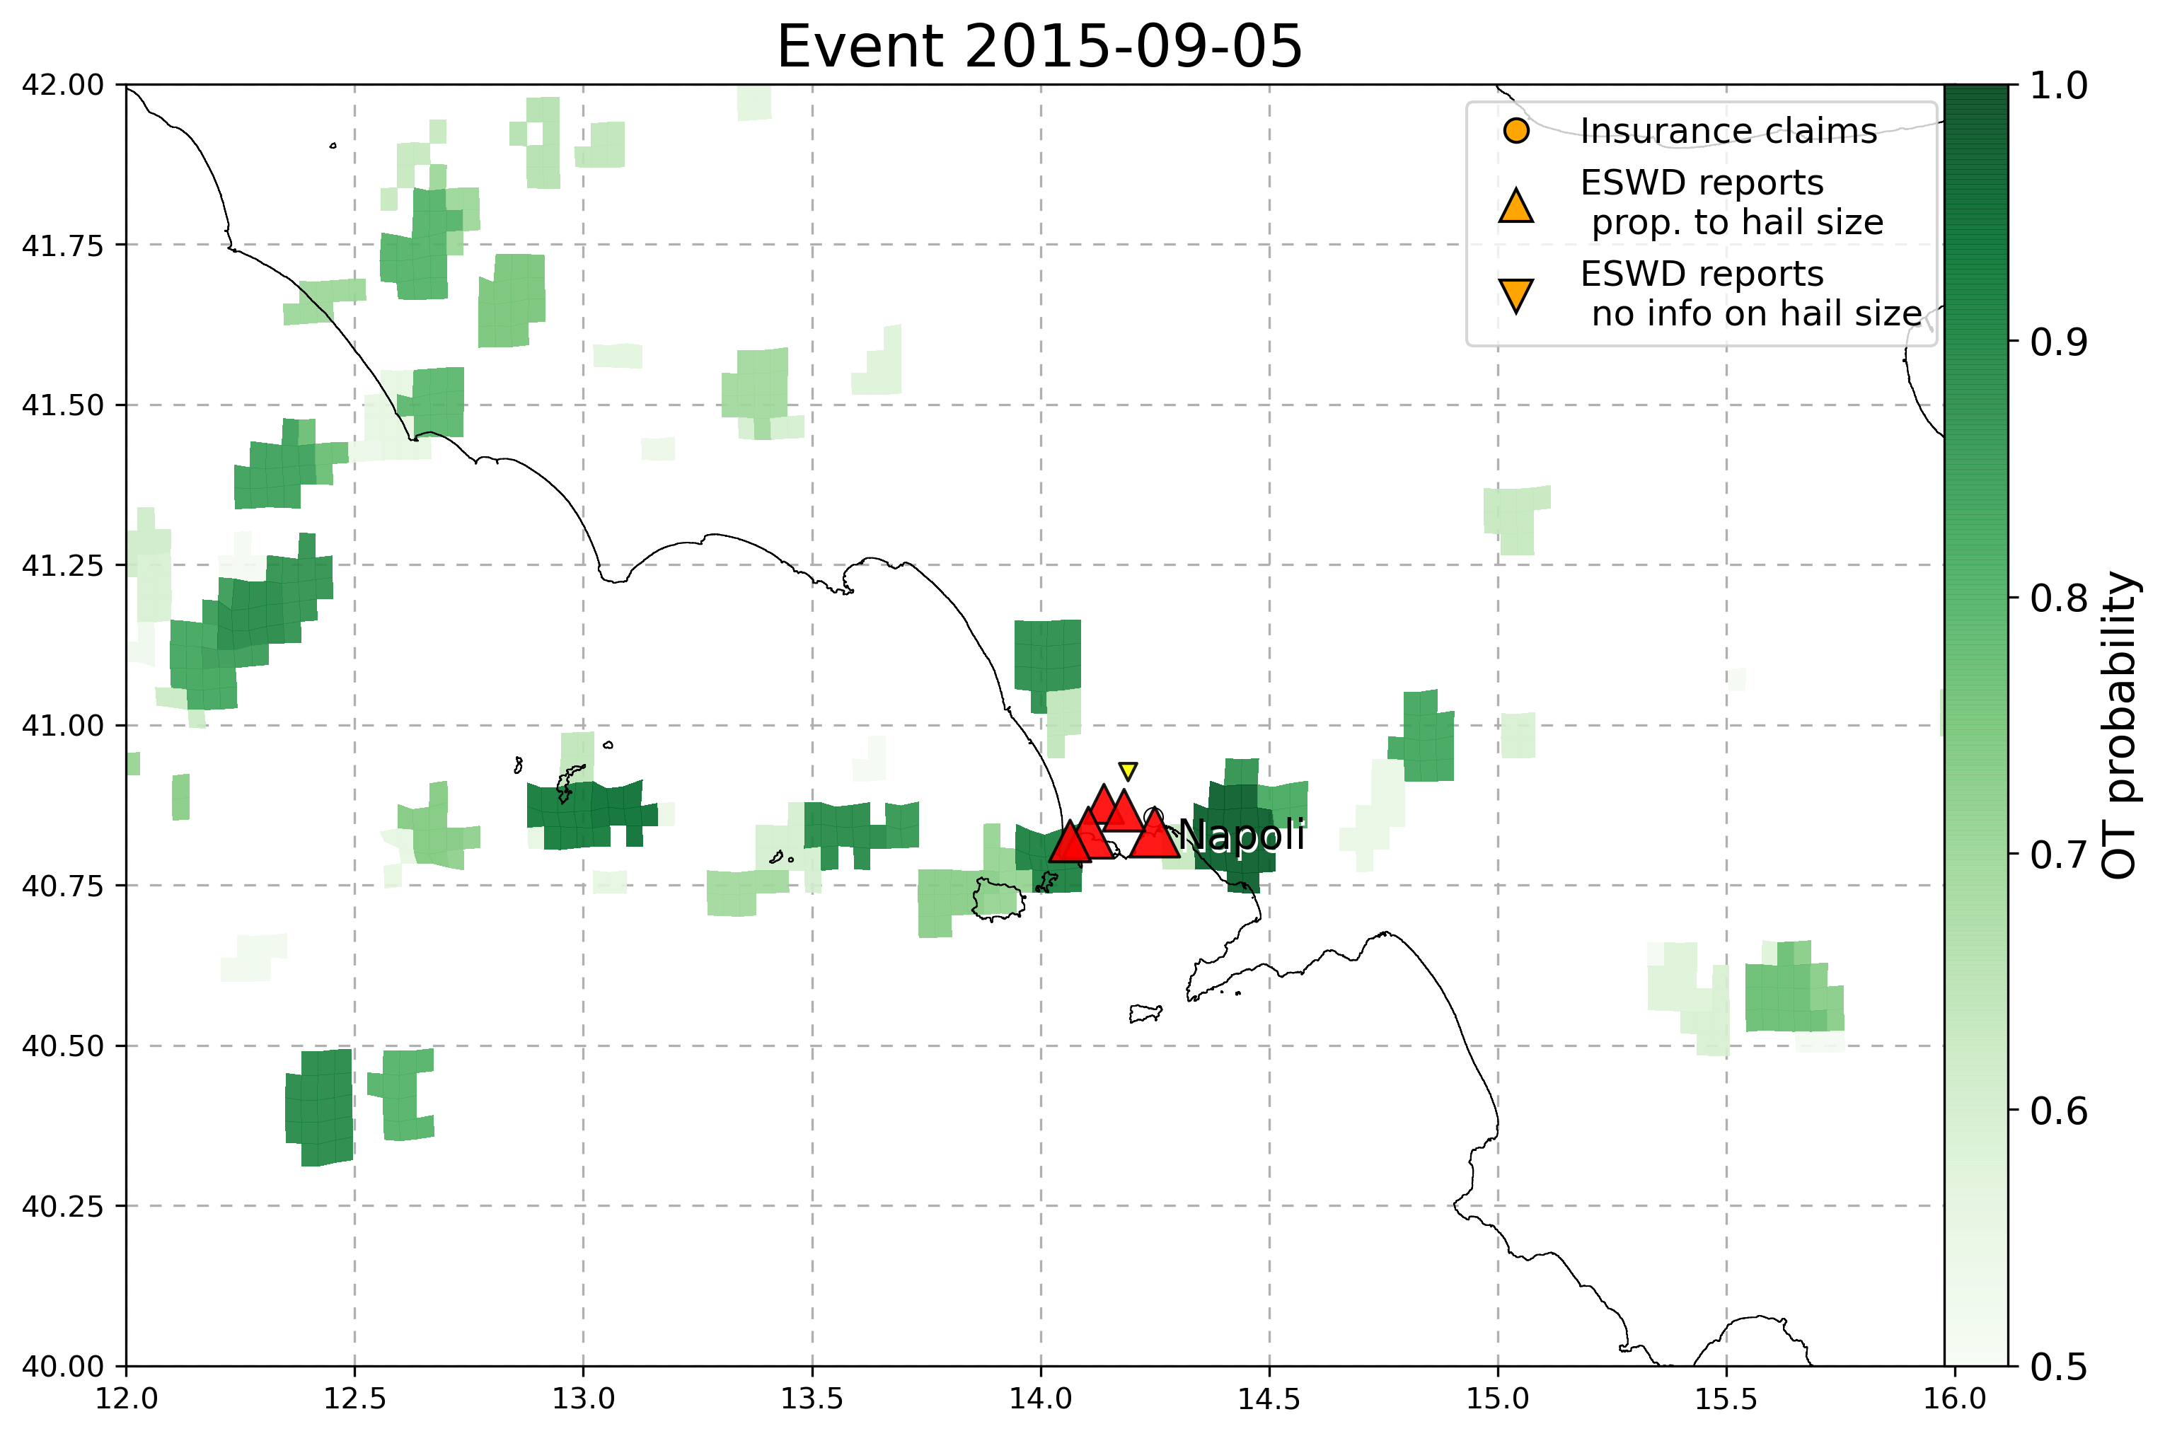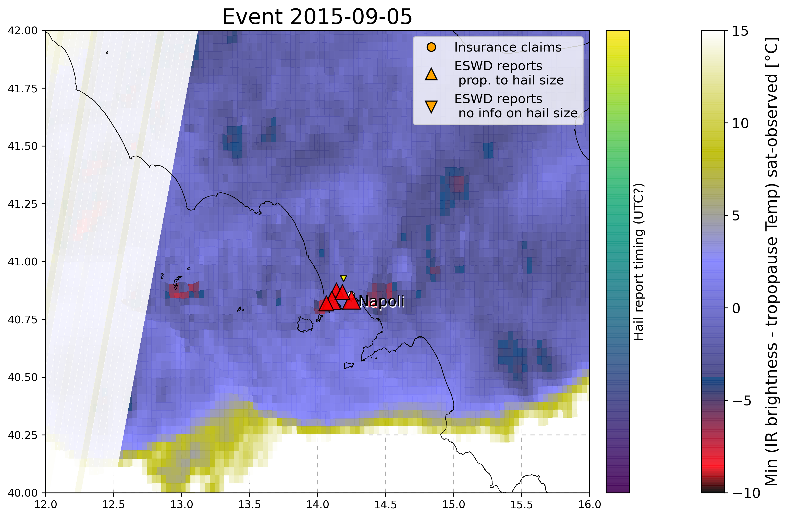

9. 6 August 2013 - Swabian Sura (SWGer) (record hail stones 14cm)  
Not correspondence with lightnings, why?

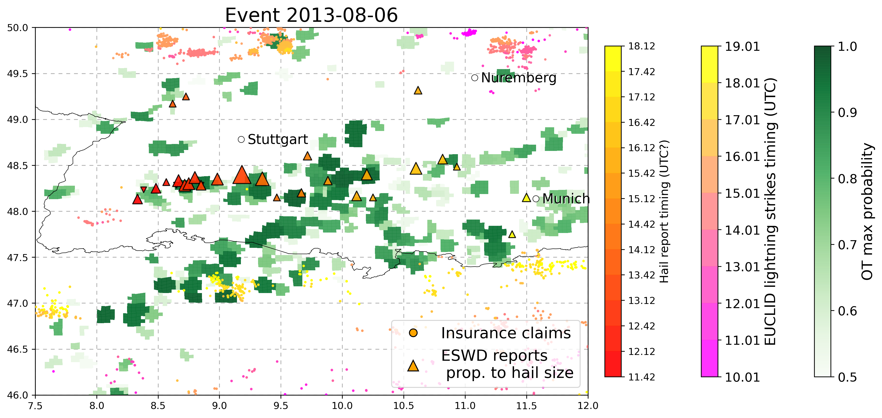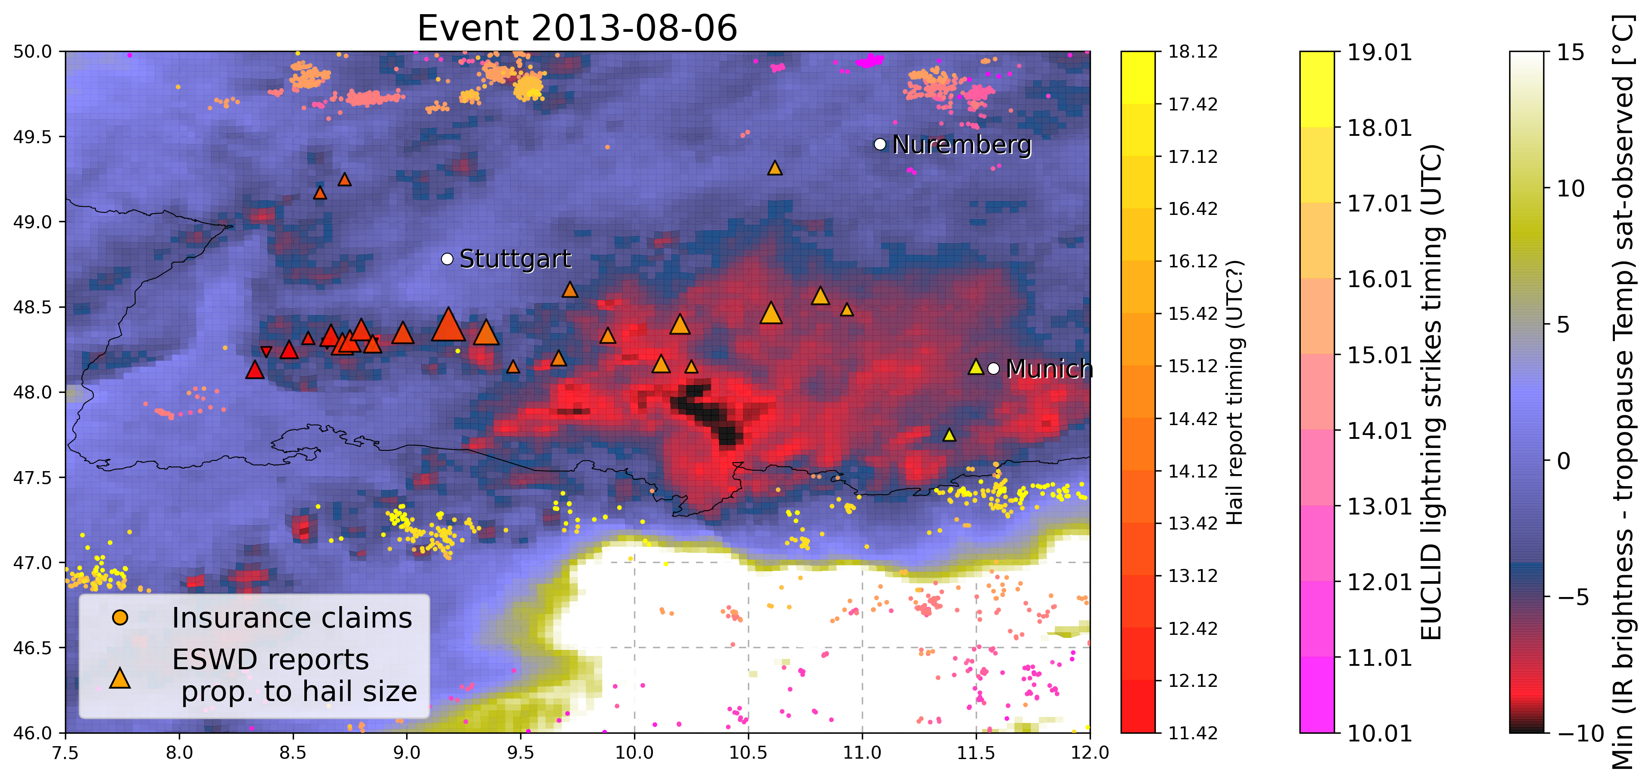

10. 28 July 2013 - Swabian Sura (SWGer)

Good correspondence between eswd, lightning temporal track and OT data! Need to insert insurance data

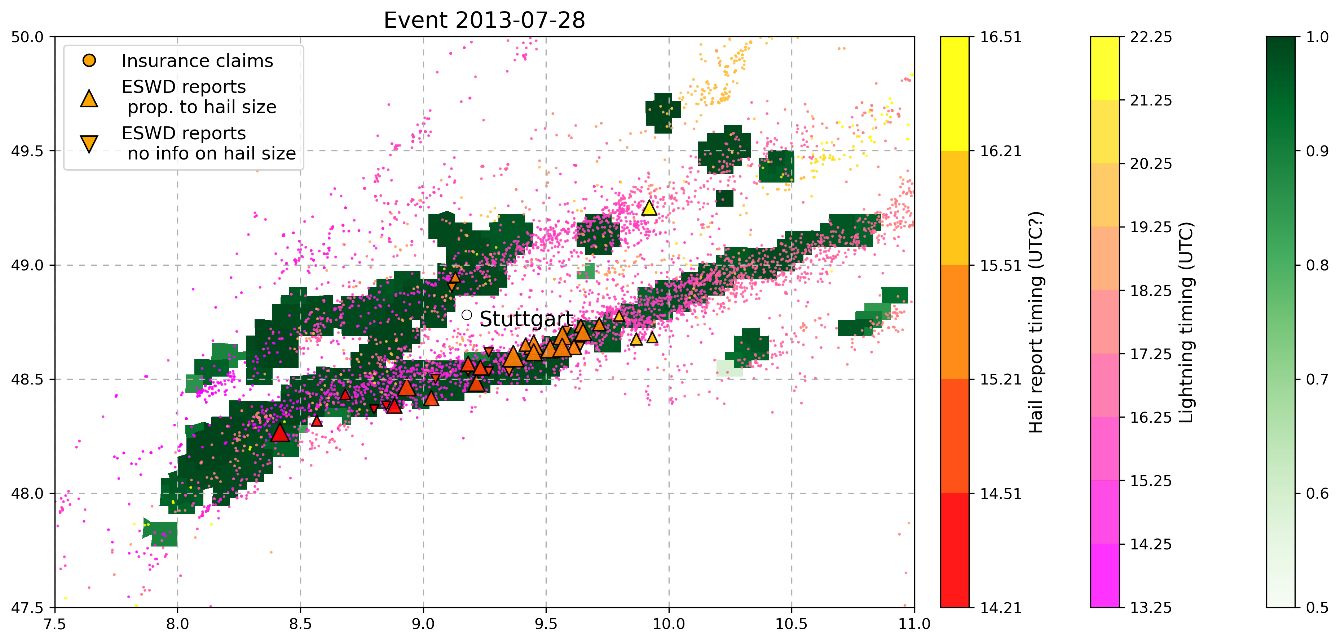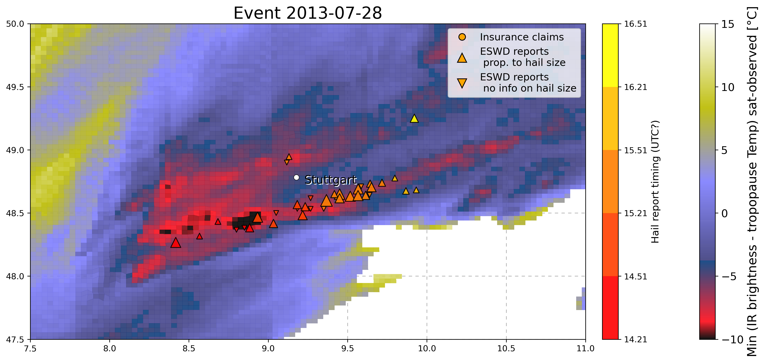

11. 23 July 2009 - Austria (max hail size 10cm, 844 million euros insured)

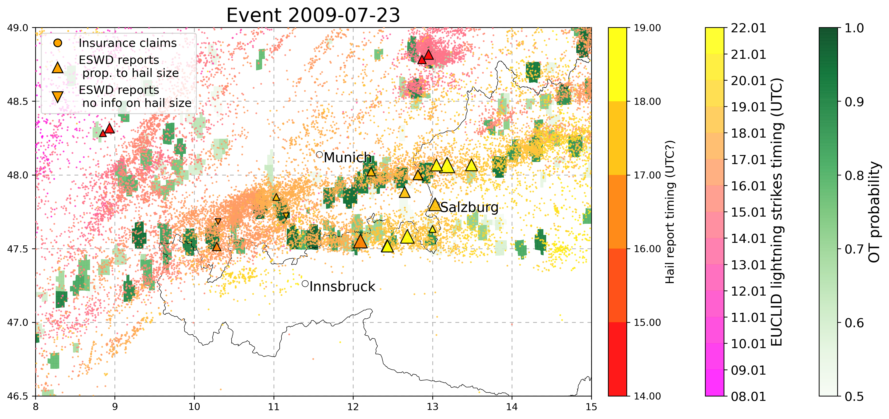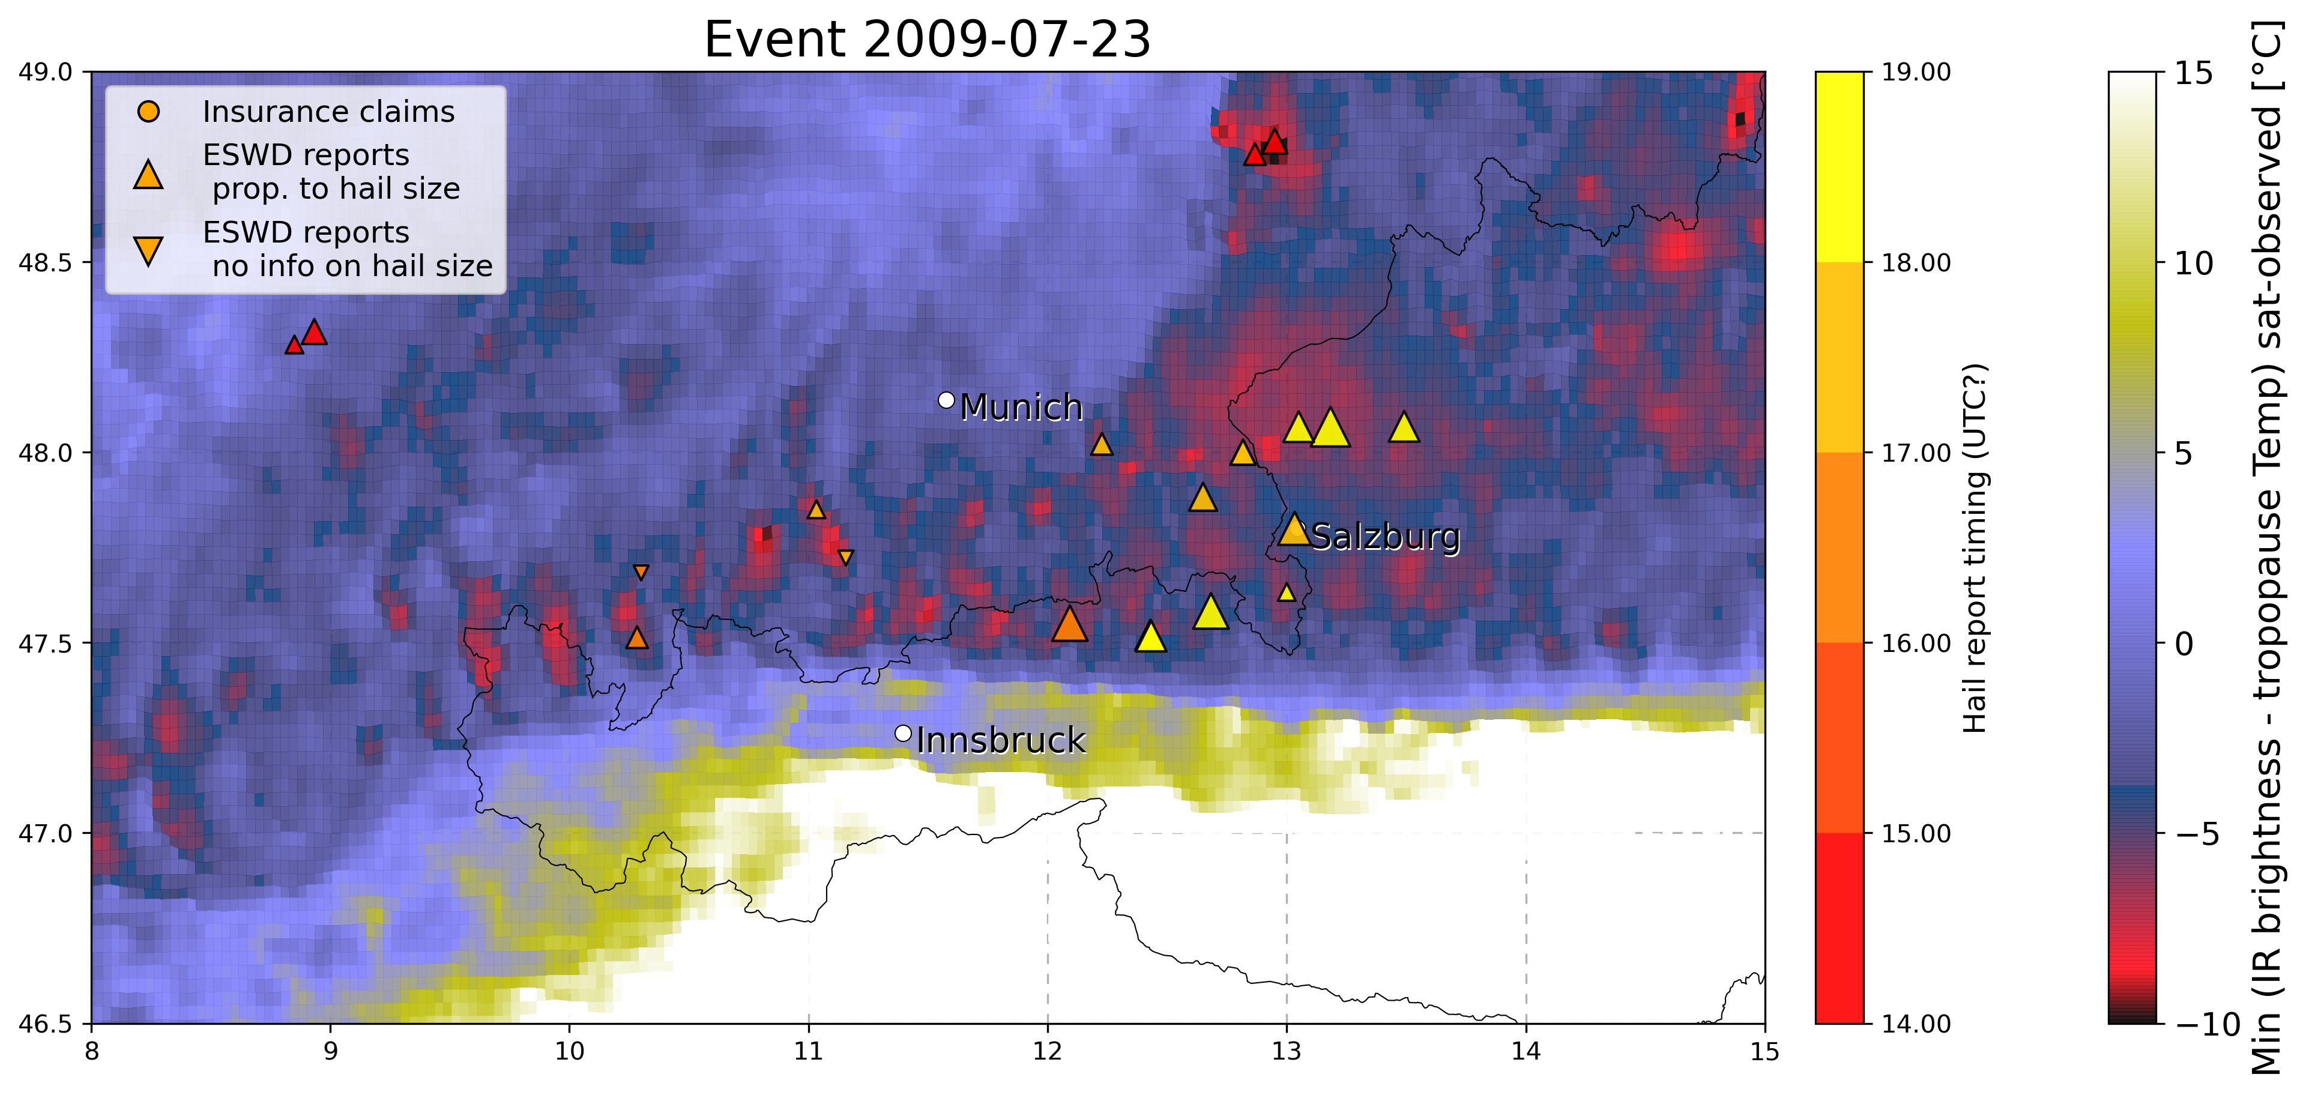

Very nice pattern! Resembles of gravity waves, **why is there some intermittency in the OT/Temp. signal??**

12. 28-29 June 2006 - SWGermany-Austria (150 million euros damage)

